****Create a shared mailbox and assign permissions to users for accessing it, Configure Retention Policies and Litigation Hold****

****What is shared mailbox?**** A shared mailbox allows multiple users to send and receive emails from a common address, such as ****support@company.com.****

****Key Features:****

1. ****Shared Access****: Multiple users can access and manage the mailbox.
2. ****Team Collaboration:****Multiple users can manage and respond emails collectively.
3. ****Send As / Send on Behalf****: Users with appropriate permissions can send emails either as the shared mailbox or on behalf of it.
4. ****Improved Response Time****: With several monitoring the inbox, inquiries are addressed more quickly.

## **1. **Create a Shared Mailbox****

* Sign in to the ****Microsoft 365 Admin center**** as a global administrator.
* In the left navigation pane, go to ****Recipients****> ****mailboxes****.
* Select ****Add a shared mailbox****.

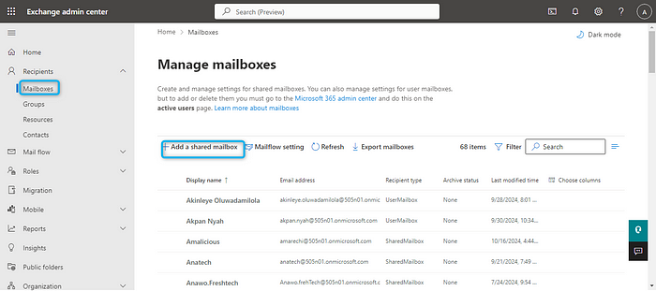

* Enter ****Mailbox name****: This will appear in the address book. ****Email address****: Create an email alias for the shared mailbox and create

## **2. **Assign Permissions to Users for Accessing the Shared Mailbox****

* Click on add users to this mailbox to add users

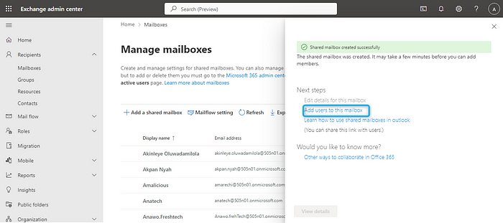

* Click on add members to select members you want to be added to the shared mailbox you just created and save

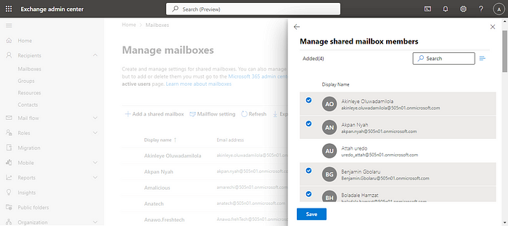

## **Assign permissions**

* Select the already created shared mailbox and click on Delegation
* ****Full Access****: Allows users to open the shared mailbox and view its contents.
* ****Send As****: Allows users to send emails as if they were the shared mailbox.

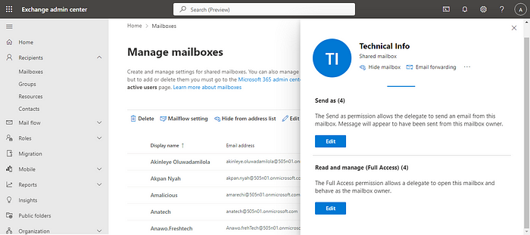

## **3. **Configure Retention Policies****

Retention policies help control how long emails or other content in the shared mailbox is retained.

First we have to create a retention tag before creating retention policy.

3.****( 3a)**** ****Retention Tags:**** define how long an item (such as an email or document) should be retained and what action should be taken when the retention period expires.

* In the Microsoft 365 admin center, go to the ****Compliance admin center****.
* Navigate to Data lifecycle management >Exchange (legacy)
* Click on MRM Retention tags to create a tag
* Select new tag, enter the tag name and description

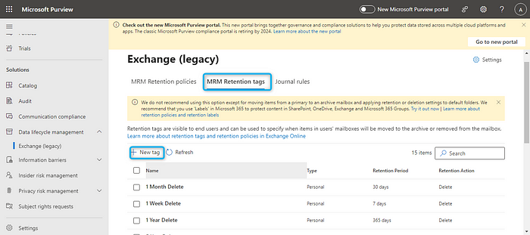

* Define how the tag will be applied and click next

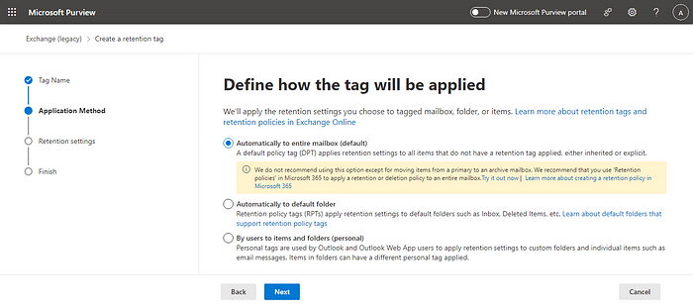

* Define retention settings and submit

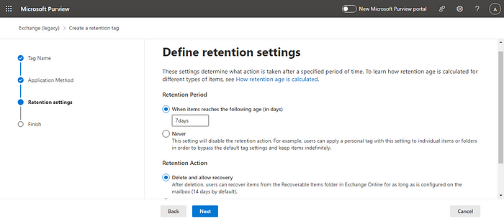

## **3. ( 3b) Retention policy Configuration**

* In the Microsoft 365 admin center, go to the ****Compliance admin center****.
* Navigate to Data lifecycle management >Exchange (legacy)
* Click on MRM Retention policies and click new policy

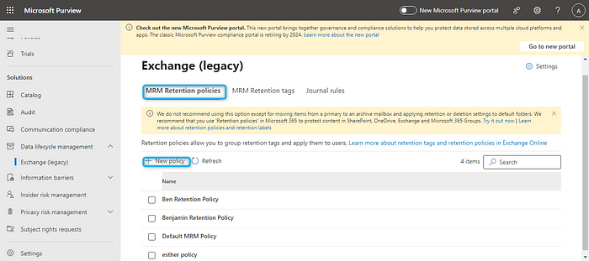

* Enter the policy name and click on add tag to choose the tag you just created and click next, review and submit

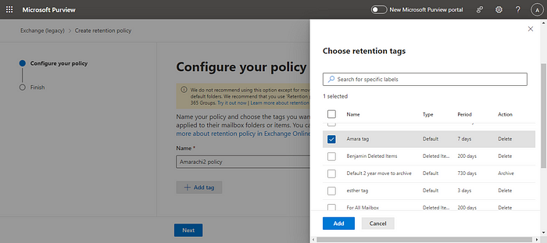

4. ****Configure Litigation Hold:****A ****Litigation Hold**** is a ****Legal Hold**** feature that allows organizations to preserve all mailbox content (emails, calendar items, tasks, etc.) to ensure that data is not altered or deleted, even if the user attempts to do so.

****Key Features:****

* ****Preserves All Content****: Litigation Hold preserves all items in a mailbox, including deleted and modified items, as well as content in the Recoverable Items folder.
* ****Applies to Deleted Items****: Even if a user deletes an email or other content, it remains in the mailbox on hold.
* ****Identification of Custodians****: Identify individuals who have control over the relevant information

## ****Configuration of Litigation hold****

* Sign in to Exchange Admin center
* Navigate to ****Recipients**** > ****Mailboxes****.
* select the mailbox you want to place on Litigation Hold and click on other

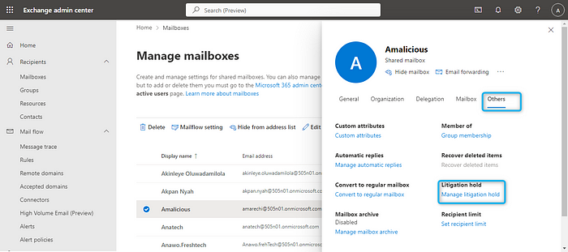

* Click on other Click on manage litigation hold then turn litigation on
* You can specify a ****hold duration**** (e.g., 365 days) or leave it blank to retain items indefinitely.

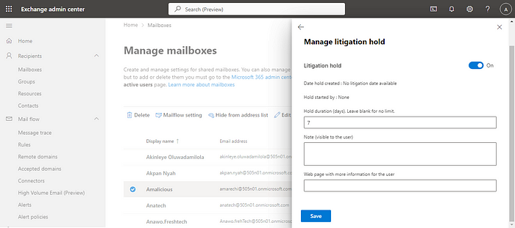

* You can add notes explaining the reason for the hold. These notes are visible to the user when they access Outlook, but they can’t remove the hold.
* Save the changes, and the mailbox will be placed on Litigation Hold.

****Create a shared mailbox and assign permissions to users for accessing it, Configure Retention Policies and Litigation Hold****

****What is shared mailbox?**** A shared mailbox allows multiple users to send and receive emails from a common address, such as ****support@company.com.****

****Key Features:****

1. ****Shared Access****: Multiple users can access and manage the mailbox.
2. ****Team Collaboration:****Multiple users can manage and respond emails collectively.
3. ****Send As / Send on Behalf****: Users with appropriate permissions can send emails either as the shared mailbox or on behalf of it.
4. ****Improved Response Time****: With several monitoring the inbox, inquiries are addressed more quickly.

## **1. **Create a Shared Mailbox****

* Sign in to the ****Microsoft 365 Admin center**** as a global administrator.
* In the left navigation pane, go to ****Recipients****> ****mailboxes****.
* Select ****Add a shared mailbox****.



* Enter ****Mailbox name****: This will appear in the address book. ****Email address****: Create an email alias for the shared mailbox and create

## **2. **Assign Permissions to Users for Accessing the Shared Mailbox****

* Click on add users to this mailbox to add users



* Click on add members to select members you want to be added to the shared mailbox you just created and save



## **Assign permissions**

* Select the already created shared mailbox and click on Delegation
* ****Full Access****: Allows users to open the shared mailbox and view its contents.
* ****Send As****: Allows users to send emails as if they were the shared mailbox.



## **3. **Configure Retention Policies****

Retention policies help control how long emails or other content in the shared mailbox is retained.

First we have to create a retention tag before creating retention policy.

3.****( 3a)**** ****Retention Tags:**** define how long an item (such as an email or document) should be retained and what action should be taken when the retention period expires.

* In the Microsoft 365 admin center, go to the ****Compliance admin center****.
* Navigate to Data lifecycle management >Exchange (legacy)
* Click on MRM Retention tags to create a tag
* Select new tag, enter the tag name and description



* Define how the tag will be applied and click next



* Define retention settings and submit



## **3. ( 3b) Retention policy Configuration**

* In the Microsoft 365 admin center, go to the ****Compliance admin center****.
* Navigate to Data lifecycle management >Exchange (legacy)
* Click on MRM Retention policies and click new policy



* Enter the policy name and click on add tag to choose the tag you just created and click next, review and submit



4. ****Configure Litigation Hold:****A ****Litigation Hold**** is a ****Legal Hold**** feature that allows organizations to preserve all mailbox content (emails, calendar items, tasks, etc.) to ensure that data is not altered or deleted, even if the user attempts to do so.

****Key Features:****

* ****Preserves All Content****: Litigation Hold preserves all items in a mailbox, including deleted and modified items, as well as content in the Recoverable Items folder.
* ****Applies to Deleted Items****: Even if a user deletes an email or other content, it remains in the mailbox on hold.
* ****Identification of Custodians****: Identify individuals who have control over the relevant information

## ****Configuration of Litigation hold****

* Sign in to Exchange Admin center
* Navigate to ****Recipients**** > ****Mailboxes****.
* select the mailbox you want to place on Litigation Hold and click on other



* Click on other Click on manage litigation hold then turn litigation on
* You can specify a ****hold duration**** (e.g., 365 days) or leave it blank to retain items indefinitely.



* You can add notes explaining the reason for the hold. These notes are visible to the user when they access Outlook, but they can’t remove the hold.
* Save the changes, and the mailbox will be placed on Litigation Hold.

****Create a shared mailbox and assign permissions to users for accessing it, Configure Retention Policies and Litigation Hold****

****What is shared mailbox?**** A shared mailbox allows multiple users to send and receive emails from a common address, such as ****support@company.com.****

****Key Features:****

1. ****Shared Access****: Multiple users can access and manage the mailbox.
2. ****Team Collaboration:****Multiple users can manage and respond emails collectively.
3. ****Send As / Send on Behalf****: Users with appropriate permissions can send emails either as the shared mailbox or on behalf of it.
4. ****Improved Response Time****: With several monitoring the inbox, inquiries are addressed more quickly.

## **1. **Create a Shared Mailbox****

* Sign in to the ****Microsoft 365 Admin center**** as a global administrator.
* In the left navigation pane, go to ****Recipients****> ****mailboxes****.
* Select ****Add a shared mailbox****.



* Enter ****Mailbox name****: This will appear in the address book. ****Email address****: Create an email alias for the shared mailbox and create

## **2. **Assign Permissions to Users for Accessing the Shared Mailbox****

* Click on add users to this mailbox to add users



* Click on add members to select members you want to be added to the shared mailbox you just created and save



## **Assign permissions**

* Select the already created shared mailbox and click on Delegation
* ****Full Access****: Allows users to open the shared mailbox and view its contents.
* ****Send As****: Allows users to send emails as if they were the shared mailbox.



## **3. **Configure Retention Policies****

Retention policies help control how long emails or other content in the shared mailbox is retained.

First we have to create a retention tag before creating retention policy.

3.****( 3a)**** ****Retention Tags:**** define how long an item (such as an email or document) should be retained and what action should be taken when the retention period expires.

* In the Microsoft 365 admin center, go to the ****Compliance admin center****.
* Navigate to Data lifecycle management >Exchange (legacy)
* Click on MRM Retention tags to create a tag
* Select new tag, enter the tag name and description



* Define how the tag will be applied and click next



* Define retention settings and submit



## **3. ( 3b) Retention policy Configuration**

* In the Microsoft 365 admin center, go to the ****Compliance admin center****.
* Navigate to Data lifecycle management >Exchange (legacy)
* Click on MRM Retention policies and click new policy



* Enter the policy name and click on add tag to choose the tag you just created and click next, review and submit



4. ****Configure Litigation Hold:****A ****Litigation Hold**** is a ****Legal Hold**** feature that allows organizations to preserve all mailbox content (emails, calendar items, tasks, etc.) to ensure that data is not altered or deleted, even if the user attempts to do so.

****Key Features:****

* ****Preserves All Content****: Litigation Hold preserves all items in a mailbox, including deleted and modified items, as well as content in the Recoverable Items folder.
* ****Applies to Deleted Items****: Even if a user deletes an email or other content, it remains in the mailbox on hold.
* ****Identification of Custodians****: Identify individuals who have control over the relevant information

## ****Configuration of Litigation hold****

* Sign in to Exchange Admin center
* Navigate to ****Recipients**** > ****Mailboxes****.
* select the mailbox you want to place on Litigation Hold and click on other



* Click on other Click on manage litigation hold then turn litigation on
* You can specify a ****hold duration**** (e.g., 365 days) or leave it blank to retain items indefinitely.



* You can add notes explaining the reason for the hold. These notes are visible to the user when they access Outlook, but they can’t remove the hold.
* Save the changes, and the mailbox will be placed on Litigation Hold.